|  |  |
| --- | --- |
| WEST LONDON WASTE AUTHORITY |  |
| Report of the Waste Minimisation Manager | 28 June 2019 |
| **Waste Minimisation Update and Plan for 2019/20** | |
| SUMMARY This report presents the proposed Waste Minimisation Plan for 2019/20 for approval and provides detail on the activities of current and upcoming projects. | |
|  | |
| **RECOMMENDATION(S)**  The Authority is asked to:   1. Approve the Waste Minimisation Plan 2019/20 2. Note the waste minimisation project activities to date | |

1. **Introduction** – Since 2010, the Authority has taken the lead role in delivering waste minimisation directions agreed by the constituent boroughs. The Waste Minimisation Plan (WMP) is a strategic result of this and the the Waste Minimisation Team is responsible for its delivery which includes the management of the Authority’s website, intranet, social media, and media communications.
2. **Background** – In light of ongoing funding pressures and to support our purpose as leaders in treating waste as a valuable resource, the WM team has been investigating innovative methods to reduce waste to relieve service pressures in the future. The WMP is project and result focused, measuring waste data changes and supported by educational and communication activity.

**3.**

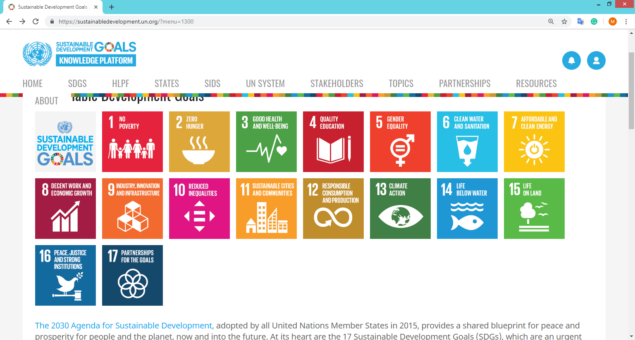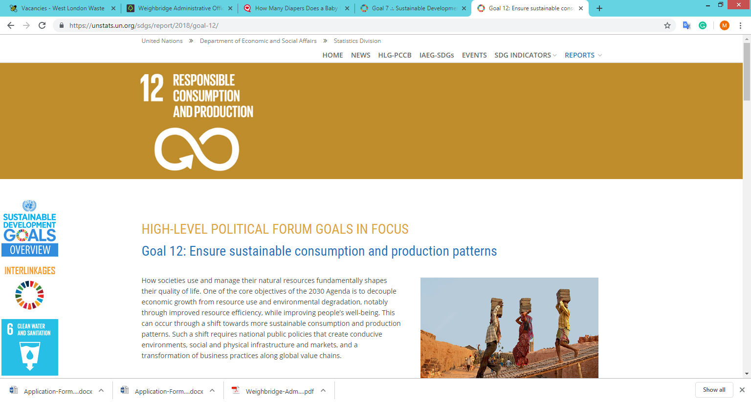**The United Nations Sustainable Development Goals** – The Waste Minimisation team has adopted   
Goal 12 (Responsible Consumption: Ensure sustainable consumption and production patterns**),** and   
Goal 17 (Partnership for the Goals): Strengthen the means of implementation and revitalize the global partnership for sustainable development to help focus our activities in future

1. **Developing the 2019/20 Waste Minimisation Plan (WMP) –** Since 2016, we have measured the composition of waste delivered to our transfer stations every 15 months to create an understanding of waste trends and the efficacy of our projects. The amount of valuable materials thrown away is increasing, despite Boroughs also collecting more than in previous years. This demonstrates a high risk of increased waste due to factors outside our control and the imperative need for extended producer responsibility beyond packaging waste. The adaptions to the WMP made in 2018 reflected borough requirements and enabled more joint working over a more extended period. The current plan will not alter for its final year, 2019/20 and the details can be seen in Appendix 1.
   1. **Food waste recycling** – Food waste recycling is a waste reduction activity and is key to increasing recycling and reducing cost. Our activities are tailored to growing the participation in a service which is entirely voluntary, particularly if residual waste is collected either weekly or fortnightly. We have developed food waste and recycling targets to aim at, specifically 4kgs recycled food waste per household per week and 1.5 kgs reduced waste per person per week compared to a baseline in 2012. WLWA is leading the field in this area as there are no published best practice targets. Decreases in tonnage collected over a 12 or 24 month period is not necessarily a negative sign because we expect recycling to become food waste reduction. When the service is ready for growth, a big push for new customers can take place. We will continue to develop projects which help us to understand how many households really participate as this will confirm or adjust our targets set.
   2. **Flats food waste recycling** – We can’t restrict residual waste collections from flats in the same way as houses. As we roll out food waste recycling for residents who live in flats, we are learning more about the natural patterns of growth and reduction in the amount of food waste collected, and the drivers and barriers for residents.

* Rolling out a new food waste service sees increases and decreases in the number of people using the service because food waste recycling is a habit and residents need support,
* No increase in tonnes collected doesn’t necessarily mean no growth in the number of participants as people also start to waste less food,
* Triggers to demotivate residents recycling food waste happen fast, therefore operational excellence is key; to collect well and to get service requests and new caddies out quickly and with no cost or quibbles.

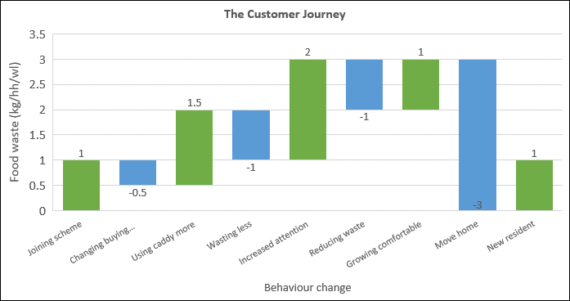

The graph above is a concept of behaviour change over time and how it affects the amount of food waste collected. This thinking will be further developed as we start new projects in 2019/20.

Our food waste recycling activities this year will continue to focus on understanding the long term trends and growing participation, including supporting the introduction of food waste recycling at five communal sites Hounslow.

The Richmond food waste recycling project completed its six-month monitoring period on the 27th of April. Each flat is producing 0.523kg of food waste for recycling per week, and our aim is to drive this up to 1kg per flat by the end of the year.

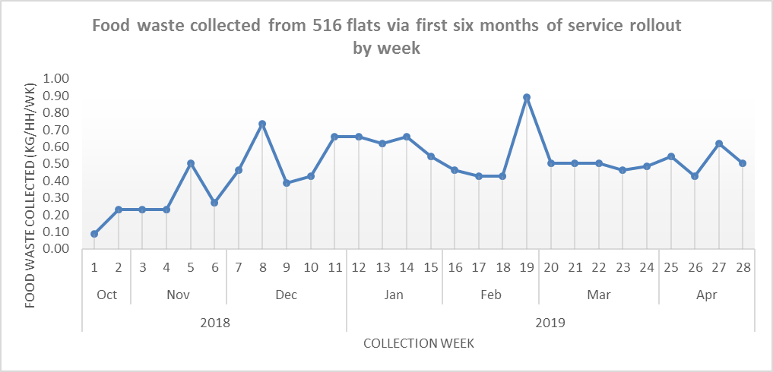

The quick tap surveys carried out in February 2019 received 191 responses, representing a 37% response rate. Of the 191 responses received, below are the core data:

|  |  |
| --- | --- |
| Mobile survey feedback | Response rate |
| Awareness of the new food waste service | 86.4% |
| Active participants of the food waste service | 70.9% |
| Indicated ‘very happy’ or ‘somewhat happy’ about new service | 88.7% |
| Dissatisfaction with the new service | 0.0% |
| Respondents producing one or two food waste liners worth of food waste per week | 74.9% |
| Main barrier as lack of equipment | 35.3% |
| Main barrier as lack of information about service | 20.9%. |

The Harrow food waste project (managed entirely by Harrow officers) rolled out to 17,000 flats in the Borough in Q4 2018/19. Collectively, the food waste service across the borough, including kerbside is yielding approximately 18 tonnes per week more than the same period last year which is a strong result and indicates more than 1kg per household per week resulting from the flats if no other changes were made. The project included an excellent crew training programme to avoid contamination of which WLWA has seen none.

* 1. **Textiles** – We have been rolling out our joint collection approach on textiles to increase the amount of textiles diverted from residual waste. Harrow Council was the most recent launch of on request textile collection on the 15th of April 2019. Due to popularity, the textile recycler is considering adding in further collection routes to manage the demand for service. Since 2017, WLWA has taken the lead relationship with textile recyclers on behalf of Boroughs to gain efficiencies and create synergy savings. Although more textile is being collected for recycling, there’s still a sharp increase in the amount of textiles found in the residual stream as shown below and actual capture rate remains low at approximately 5.32%.

The plan for the upcoming year is to continue to develop connections between borough partners and various textile recyclers further and explore ways to optimise textile collections across West London. This includes:

* Expanding on-request and kerbside textile collections to new boroughs and carrying out various pilot projects with Brent and Hillingdon Councils.
* Carrying out a gap analysis of textile banks and install more placements
* Improving existing textile recycling communications within each borough
* Running a brand new competition to win an upcycled wedding dress
* Continuing with swishing events and expanding on repair workshops

WLWA & E&W Couture have joined forces to produce an intricate upcycled wedding dress made from fabrics and offcuts generously donated by Arcadia Group & TRAID. One lucky west London resident will win this exquisite wedding dress with an RRP of £3000. Residents can enter to win this upcycled dress by booking via online or over the telephone and completing a free TRAID home collection between the 23rd of April to 22nd of September 2019. The campaign includes poster/leaflet advertisement, online social media activities and the touring of the wedding dress.

* 1. **WEEE** - The Defra funded trial demonstrated that the cost of home collections is too much for Boroughs to take on without additional funding from Producers. It also indicated that the publicity associated with home collections increased the amount of WEEE collected by other means too.

The Waste Minimisation Team continues to provide support for WEEE drives:

* St Richard’s school in Ham, Richmond collected 40kg of WEEE items in April 2019
* Two Repair Cafes including a WEEE collection, in Brent and in Richmond collected a total of 20kg of WEEE.
* WLWA is currently in discussion with Brent Council to pilot a combined WEEE and textile collection. Pilot start date is yet to be confirmed.

WEEE tonnes collected at HRRCs is steady.

But on a per household basis, more WEEE continues to be found in the residual waste stream than collected at HRRCs.

We are seeking additional funding and investigating options for collection schemes that guarantee data security. The government will be seeking views by the end of 2020 on extending producer responsibility in the Weee regulations.

* 1. **Reusable Nappies** – We have continued to develop the “try before you buy” nappy packs for residents and have learned how to streamline our offer and get more packs out to residents. The uptake of the reusable nappies scheme continues to grow. We have streamlined our operation to cover two boroughs each month, implemented an electronic system for members of the public to book into drop-in sessions and collected loan scheme feedback using mobile surveys.

The feedback currently shows that 85% of trial pack users are happy with the service, 93% of trial users found the washable nappies and accessories easy to use and would recommend them to others. Lastly, 79% of users indicated they will continue with reusable nappies and will purchase their own.

2019 half year application figures are strong, but clearly this is a niche service and we need legislative change to drive real behaviour change.

* 1. **Increasing recycling from flats**

WLWA will be providing support to improve recycling participation and quality across approximately 1,597 flatted properties in Hounslow and 2,138 flatted properties in Hillingdon. We will use the quick tap surveys to gain insight from residents and carry out receptacle inventories.

* 1. **Communications –** WLWAcontinues tobe shortlisted for awards. In 2017/18 for Partnership at the National Recycling Awards. In 2018/19 for the Best Team of the Year with edie Sustainability Leaders Forum and Campaign of the year at the National Recycling Awards for Harrow Council’s WEEE collection pilot.

WLWA is building its profile in the industry with presentations made to various industry groups and conferences on: partnership and joint working, re-use and the need for the legislative change, the importance of quality of recycling and understanding the impact of extended producer responsibility. This year our focus will build on the existing themes and add: reducing food waste, the challenge of flats recycling, avoidable waste and the importance of waste data.

The Waste Minimisation team will be providing environmental focussed mentoring service during July and August 2019 for groups of 80 youths with the National Citizen Service across Ealing, Hounslow, Hillingdon and Richmond upon Thames.

In addition, the team is working with the community group, Plastic Free Ruislip and its pop-up shop in Hillingdon to promote waste minimisation activities in the local areas further.

|  |  |  |
| --- | --- | --- |
| Contact Officers | Mildred Jeakins, Waste Minimisation Manager  [mildredjeakins@westlondonwaste.gov.uk](mailto:mildredjeakins@westlondonwaste.gov.uk) | 01895 546 623 |
| Emma Beal, Managing Director  [emmabeal@westlondonwaste.gov.uk](mailto:emmabeal@westlondonwaste.gov.uk) | 01895 545 515 |

**Appendix 1 – Waste Minimisation Plan 2018/2020**

